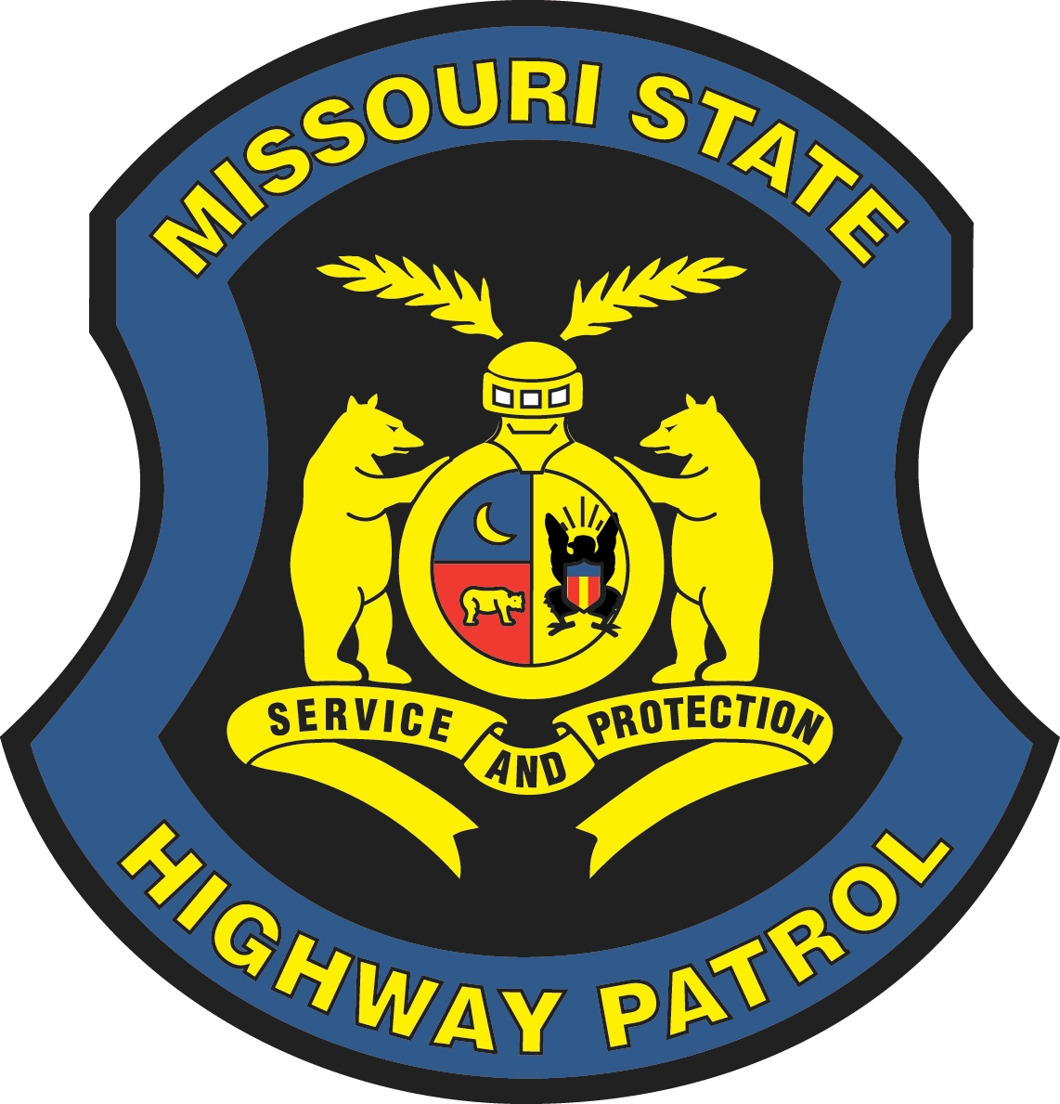
MISSOURI STATE HIGHWAY PATROL

STUDENT INTERNSHIP ESSAY

Please provide responses to each question below and submit as an attachment with your completed application. The responses should be double-spaced and twelve-point font.

1. What career field(s) are you interested in pursuing?

2. How will your internship assist you in learning, specifically in ways the classroom cannot?

3. What are your future career goals and how will your internship contribute to achieving these goals?

4. How will your internship benefit the Missouri State Highway Patrol?

5. What specific skills do you have that will lead to continued success of the Missouri State Highway Patrol?

